## Shopify Account Creation and Admin Dashboard Exploration

A Shopify account was created using the free trial option. After successful login, the Shopify Admin Dashboard was explored to understand store management features.

### Admin Dashboard Overview

The admin panel provides access to orders, products, customers, analytics, marketing, and store settings.

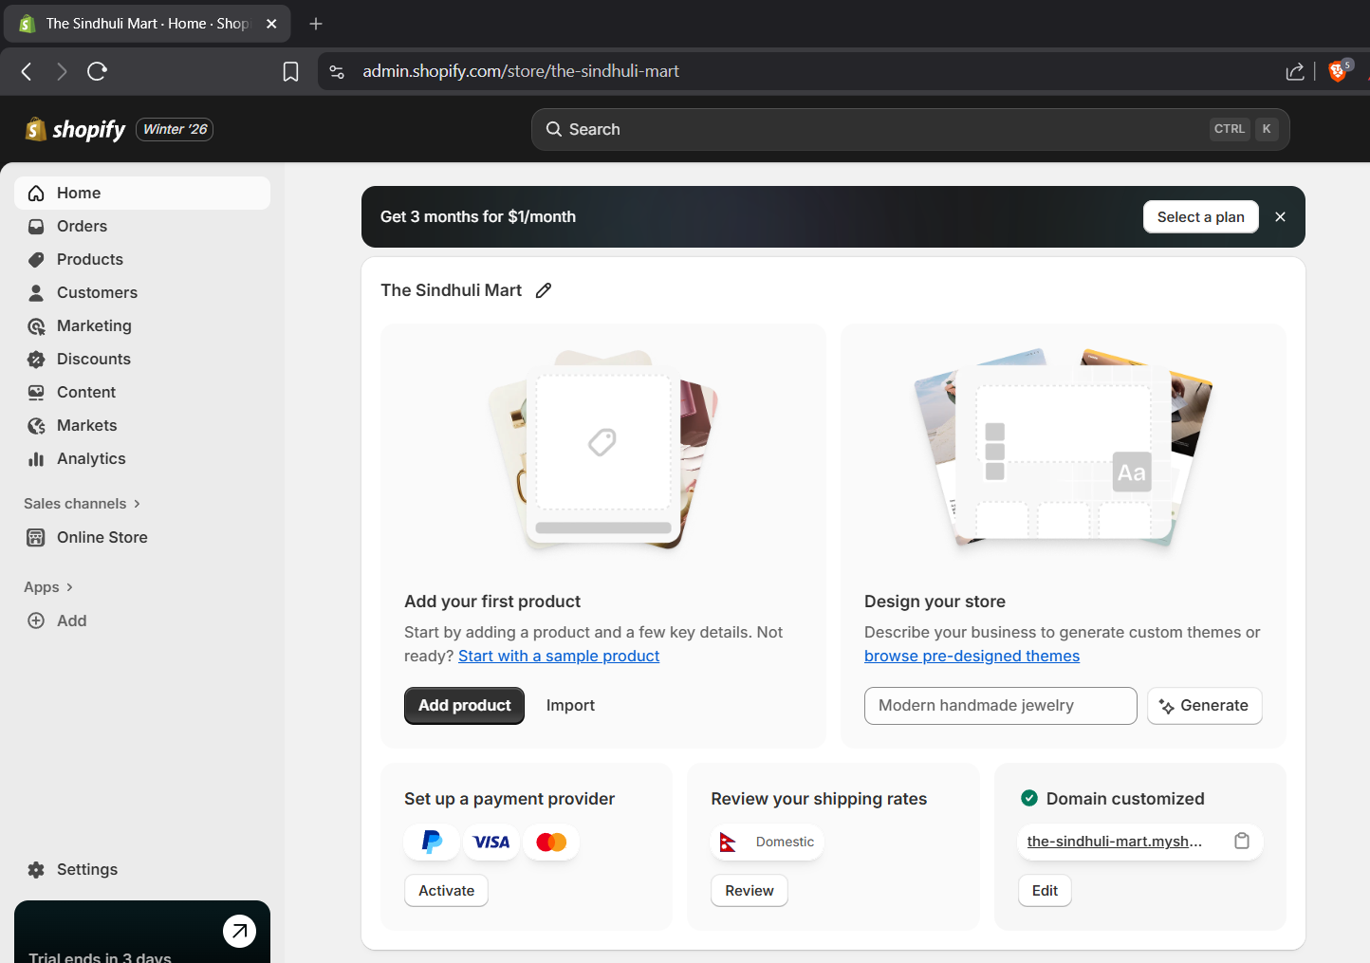

Figure 1: Admin Dashboard

**Key Observations:**

Order Confirmation Notifications: Automatic notifications are generated when a customer places an order, ensuring real-time order tracking.

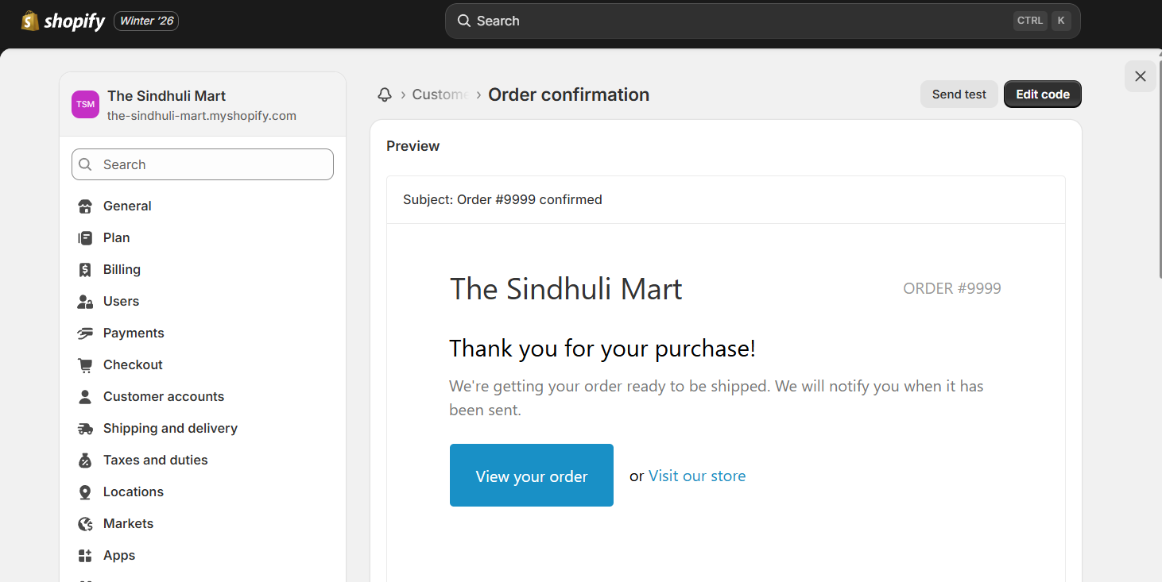

Figure 2: Order Confirmation Style

Delivery Rate: The dashboard displays delivery and fulfillment status, helping track order completion efficiency.

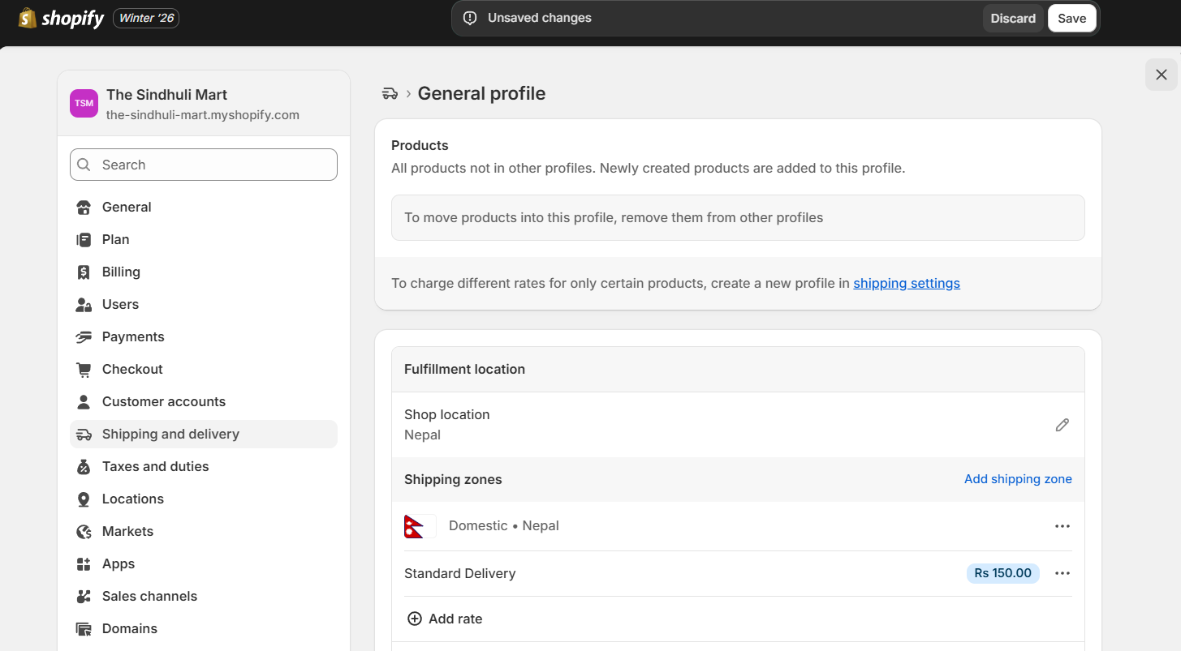

Figure 3: Delivery Rate

## Theme Selection and Storefront Customization

### Theme Selection

A theme was selected from the Shopify theme library and applied to the store.

Customization Process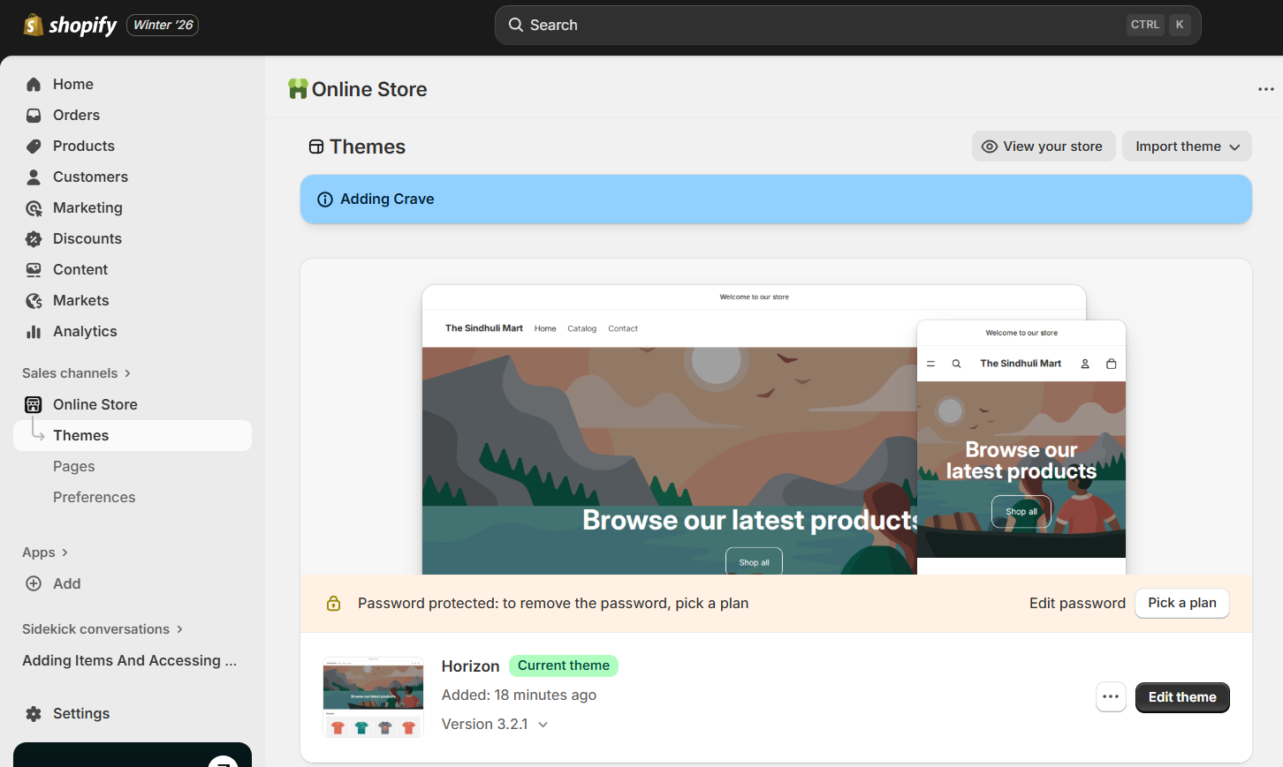

Figure 4: Themes in Shopify

Before Customization

1. Default theme layout
2. Standard color scheme
3. No logo
4. Default background and typography
5. A screenshot of the store before customization was taken.

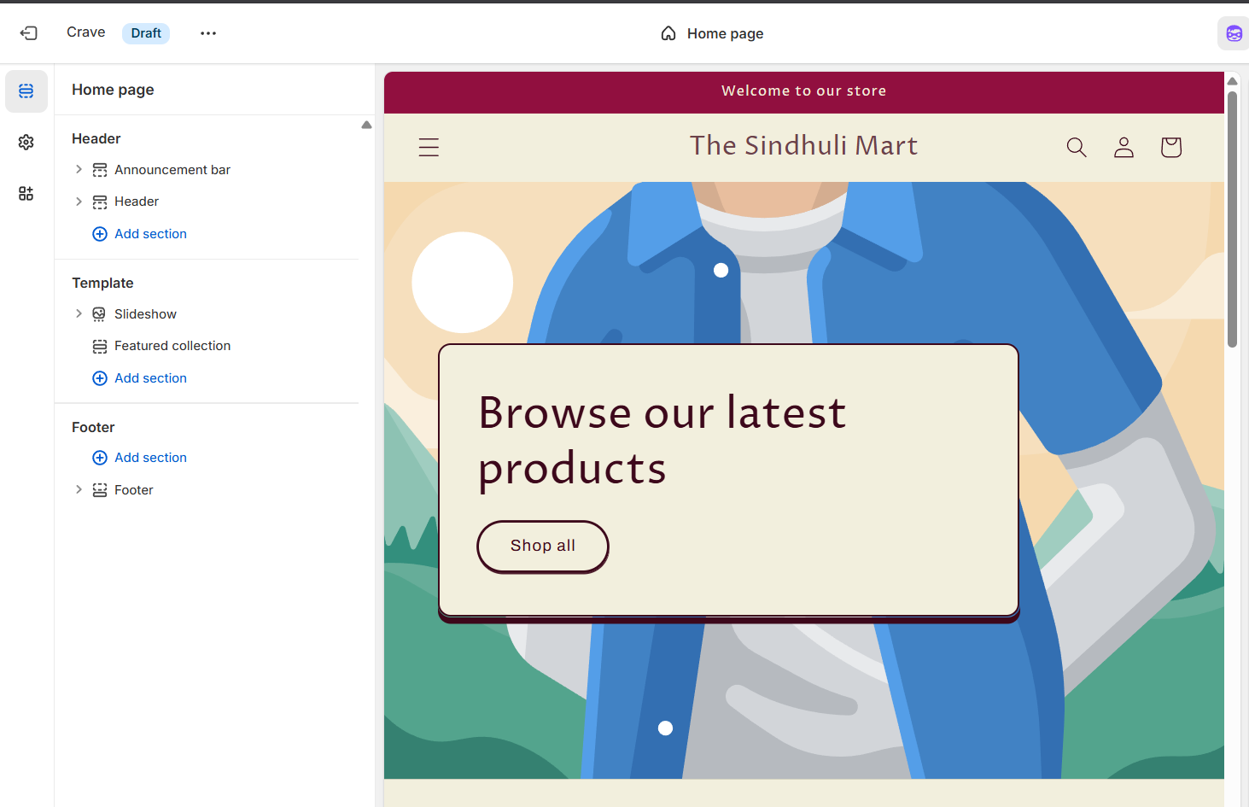

Figure 5: Before Customization

After Customization

1. Customization was applied to improve branding and visual appeal.
2. Changes Made:
   1. Updated background images and positioning
   2. Modified color themes
   3. Added store logo
   4. Adjusted layout for better responsiveness

**Desktop View**

The homepage layout was optimized for desktop screens, ensuring proper alignment and spacing.

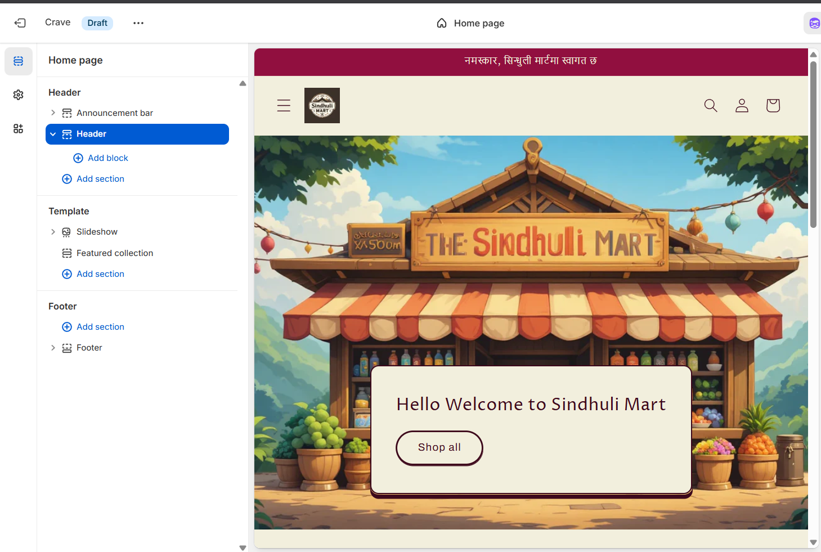

Figure 6: Desktop View After Customization

**Mobile View**

The mobile layout was adjusted to maintain readability and usability on smaller screens.

1. Theme Customization (Before)
2. Customization (After)
3. Desktop View
4. Mobile View

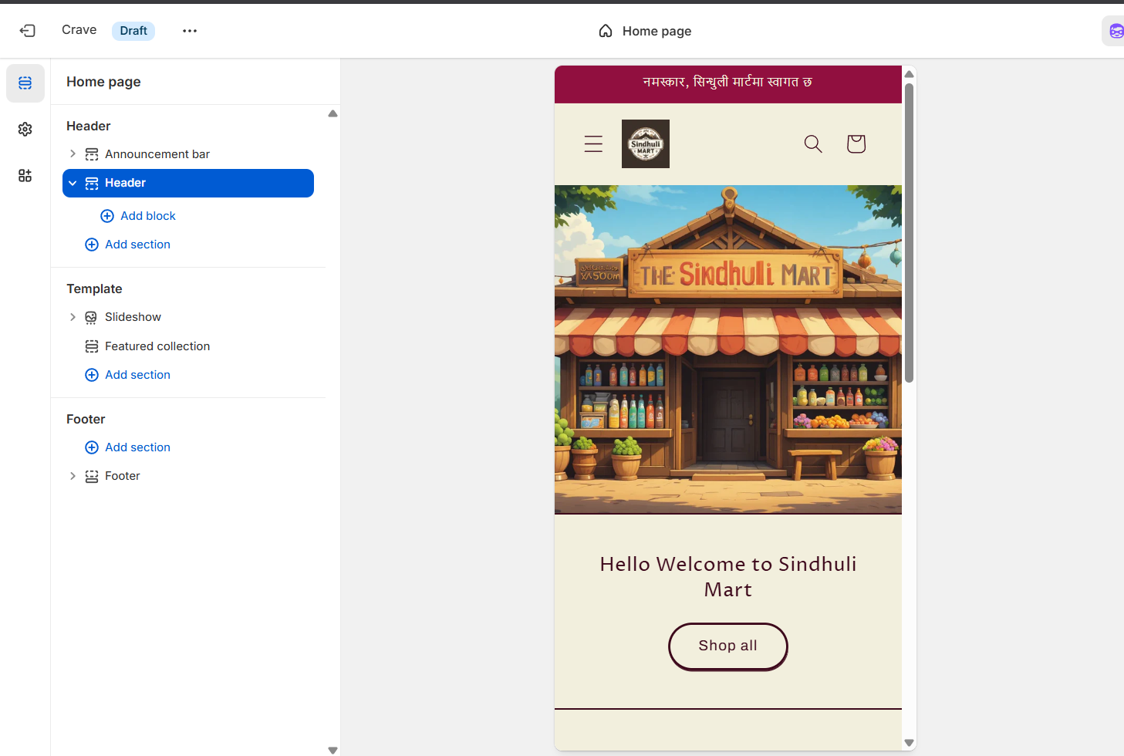

Figure 7: Mobile View After Customization

## Adding Products to the Store

A minimum of five products were added to the Shopify store.

Each product includes the following details:

1. Product title
2. Product image
3. Description
4. Price
5. Stock quantity

These details allow proper display and inventory management within the store.

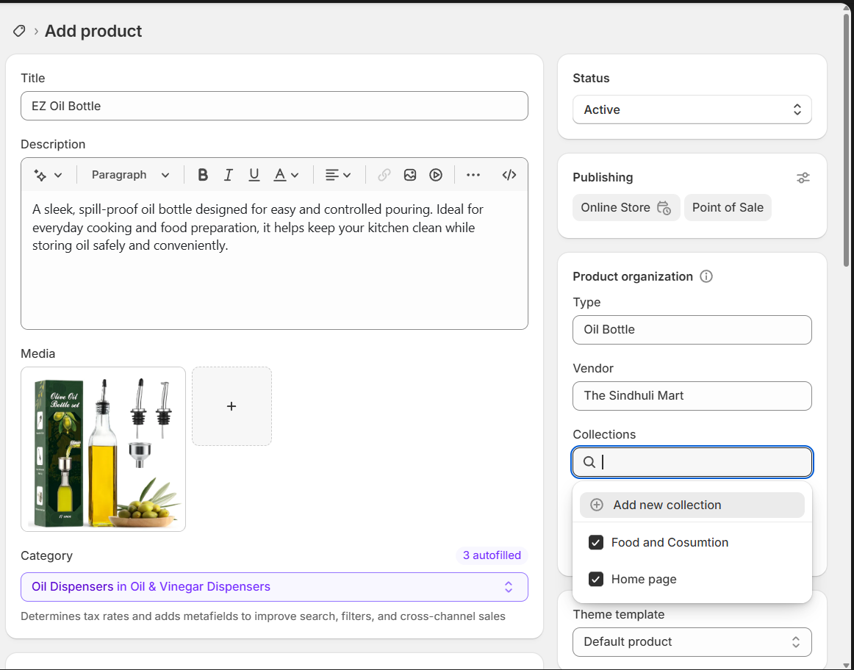

Figure 8: Adding Product

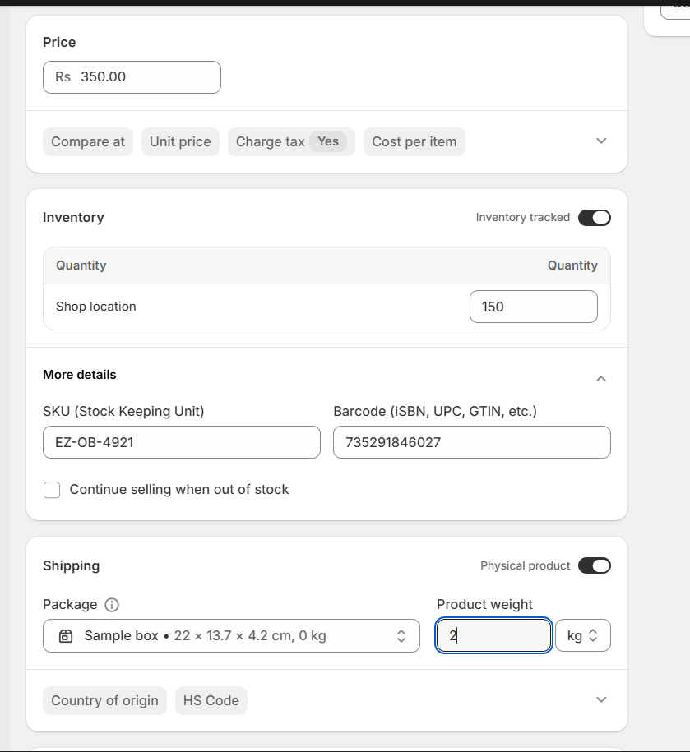

Figure 9: Product Details while Adding Product

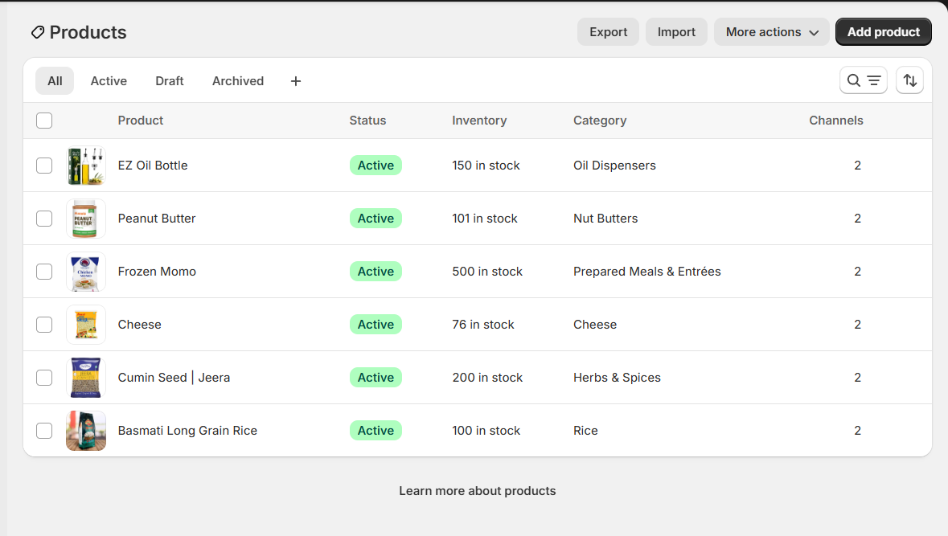

Figure 10: List of Products

### Product Collections

Creating Collections

1. Product collections were created to organize related products.

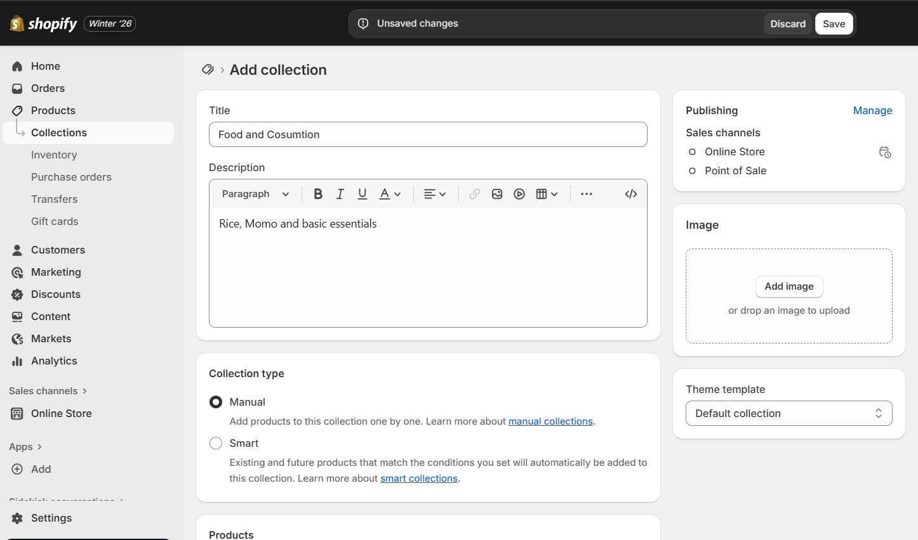

Figure 11: Creation of Collection

1. Adding Products to Collections

Products were assigned to appropriate collections for easier navigation and better customer experience.

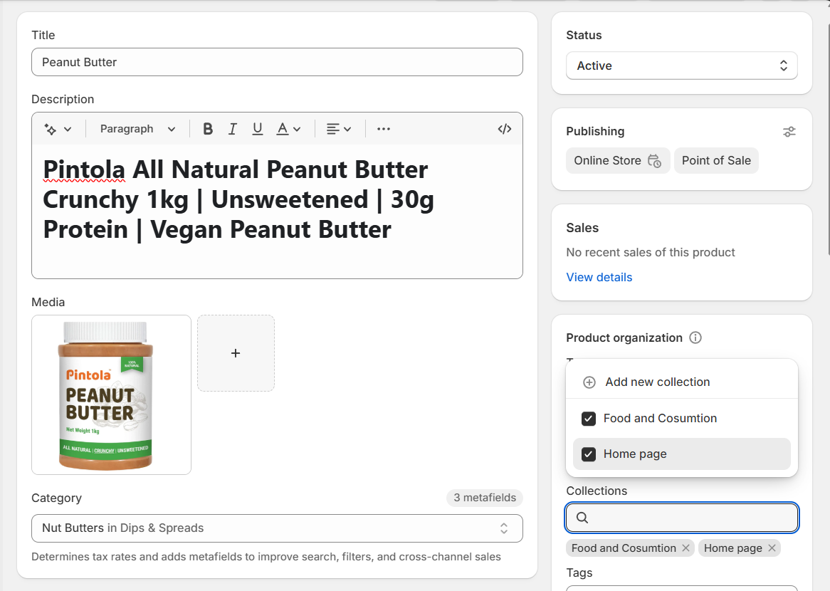

Figure 12: Addition Products to Collection

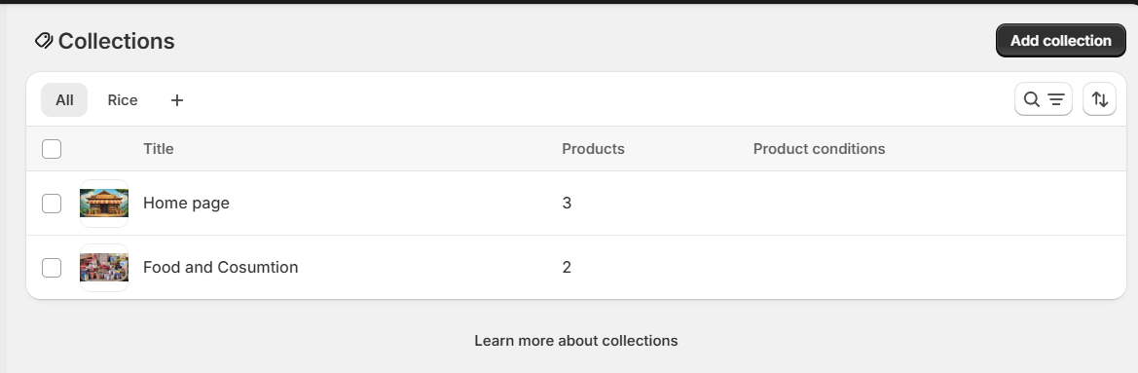

Figure 13: Product Collections

## Navigation Menu Configuration

1. Navigation menus were configured from the Shopify admin panel.
2. Menu Links Created:
   1. Home
   2. Products
   3. About
   4. Contact
   5. Menu Display

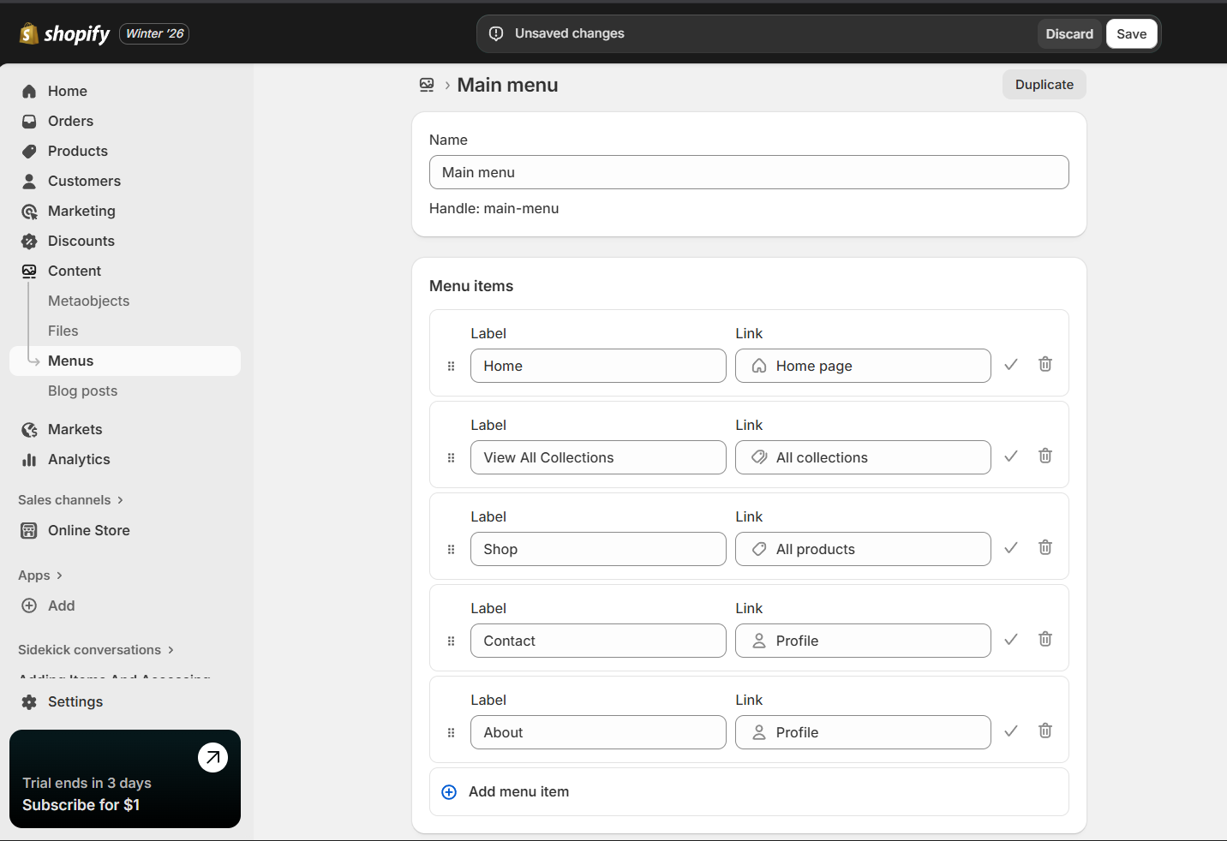

Figure 14: Navigation Menu

1. Menus were displayed correctly on the storefront

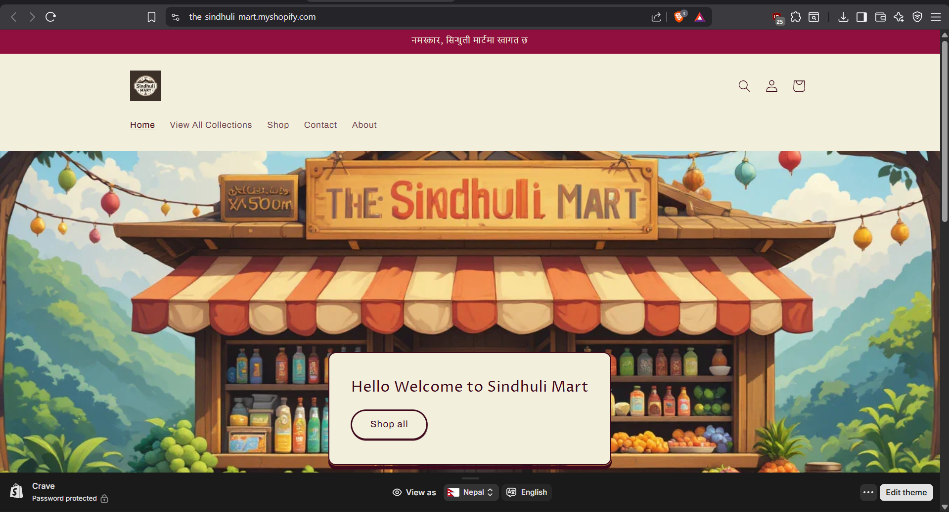

Figure 15: Navigation in Desktop View

1. Mobile-friendly navigation was verified

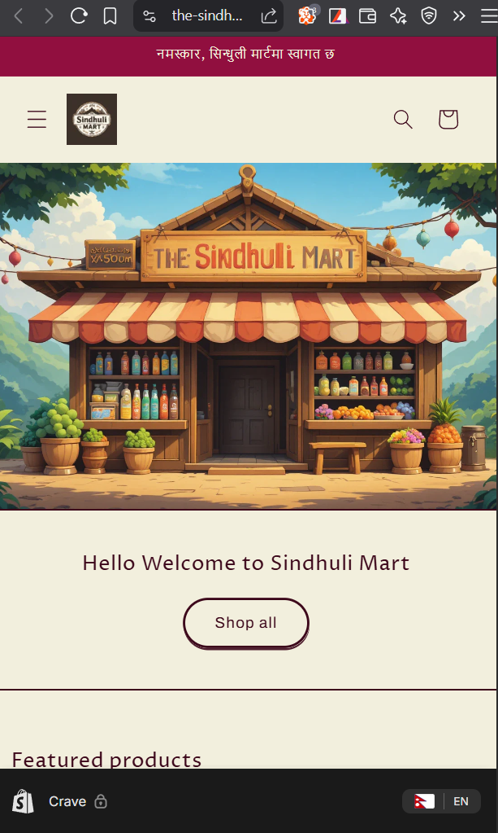

Figure 16: Mobile View

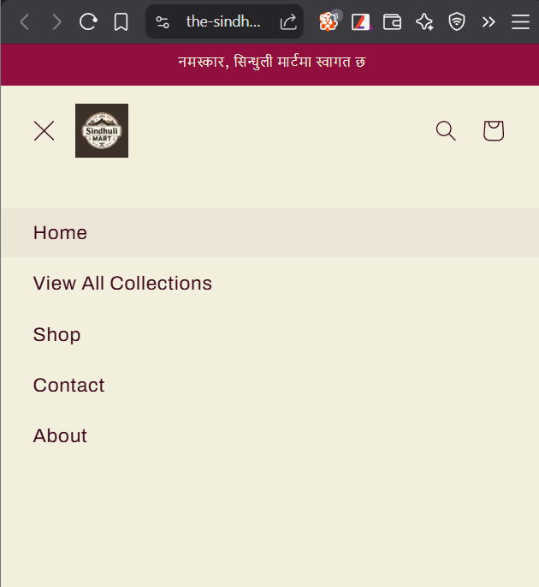

Figure 17: Navigation for Mobile View

## Create Discount Code

1. Opened the Discounts section from the Shopify admin panel and initiated the option to add a new discount.
2. Selected a suitable discount category, specifically an order-level amount reduction.
3. Created the discount code either by using Shopify’s auto-generation feature or by entering a custom code.
4. Defined the discount rules by setting customer eligibility, minimum order value, and usage restrictions.
5. Specified the activation period by assigning start and expiration dates.
6. Finalized and saved the settings to make the discount active.

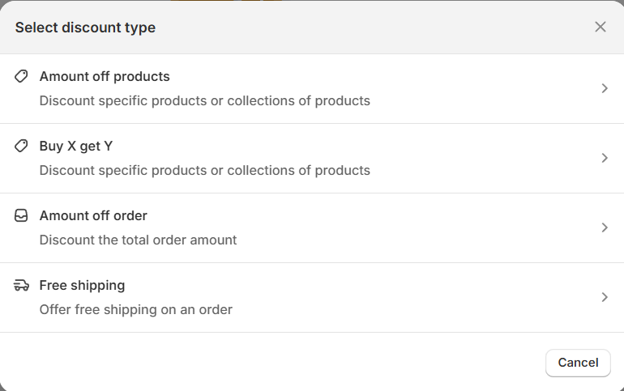

Figure 18: Discount Type Selection

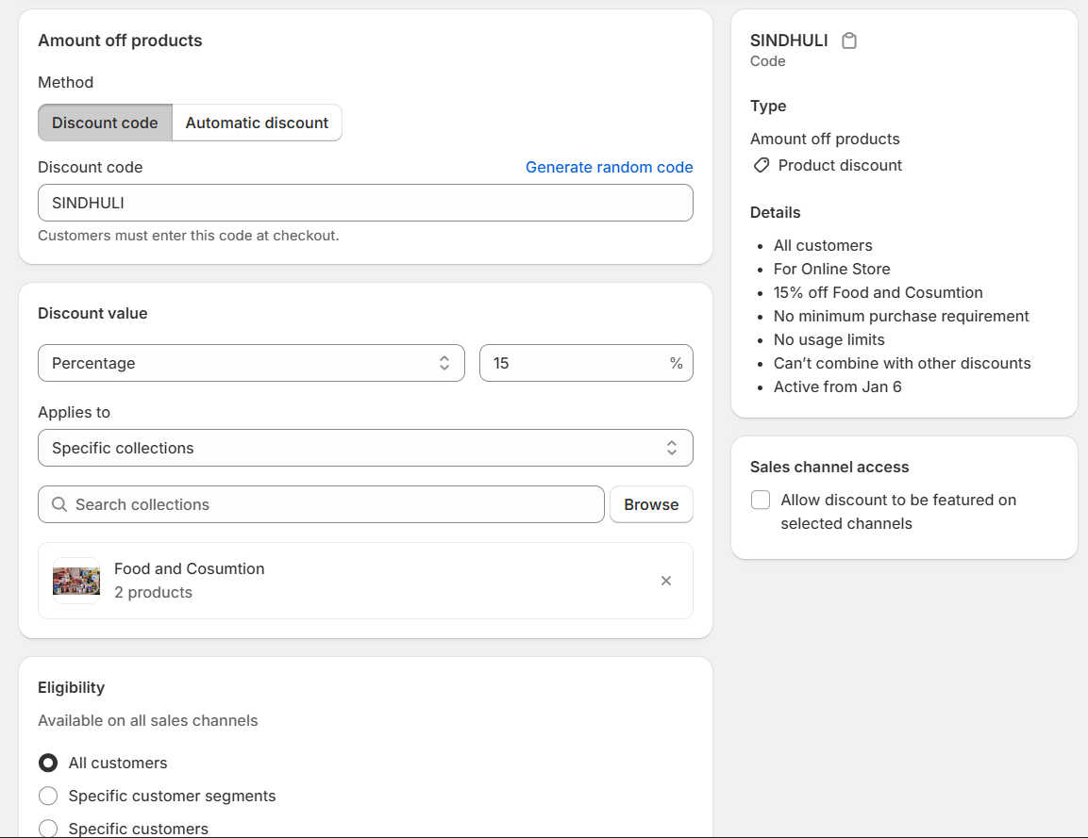

Figure 19: Discount Upon Products

## Install and Explore any App from Shopify App Store

### Installation of Shopify Inbox

1. Logged into the Shopify Admin Dashboard.
2. Navigated to the Shopify App Store from the dashboard menu.
3. Searched for “Shopify Inbox” using the search bar.
4. Selected the app from the search results and clicked Add App.
5. Confirmed the installation by clicking Install App, which automatically integrated Shopify Inbox with the store.
6. After installation, the app was accessible directly from the Shopify dashboard, ready for use.

The installation process was straightforward and required no additional configuration. Shopify Inbox connected automatically to the store, allowing immediate access to basic chat features such as live messaging and automated greetings. This demonstrates how Shopify apps can be quickly added to a store to extend functionality with minimal effort.

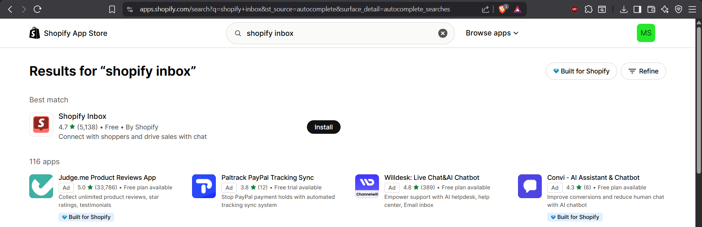

Figure 20: Shopify Store

A free application, Shopify Inbox, was searched and installed from the Shopify App Store to explore its customer communication functionality. After installation, the app was automatically connected to the Shopify dashboard, allowing access to basic customer interaction features.

.

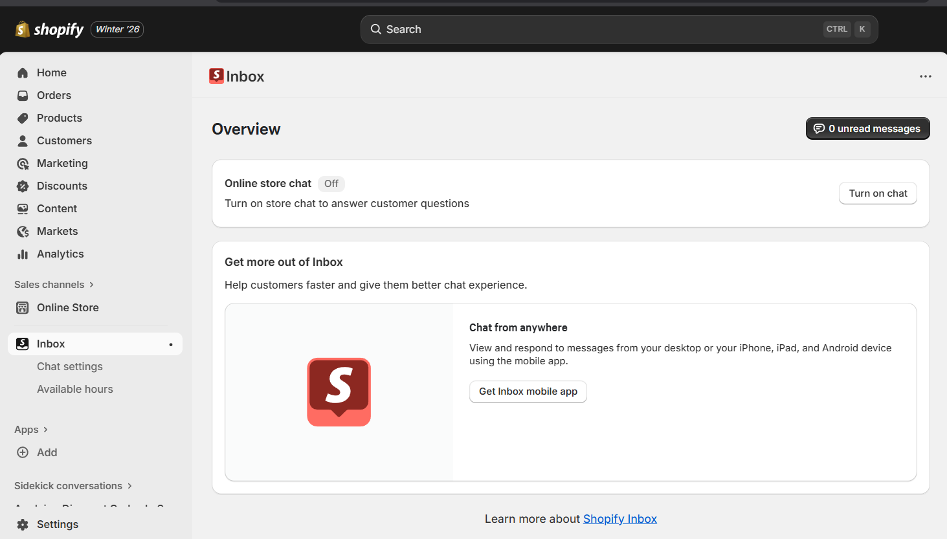

Figure 21: Shopify Inbox

The app interface was briefly explored to understand its core features, including live chat, automated greetings, and message tracking. A test conversation was initiated to demonstrate the app’s communication capability. This simple exploration illustrated how Shopify Inbox can be used to interact with customers and support basic store communication

## Set Up a Blog on Shopify Store

1. Navigated to the Apps section in the Shopify admin dashboard and selected Shopify Inbox to manage customer communication.
2. Clicked on Add App to install Shopify Inbox from the Shopify App Store.
3. Confirmed installation and accessed the Inbox dashboard directly from the Shopify admin panel.
4. Explored the interface to understand core features, including live chat, automated greetings, and message tracking.
5. Tested sending a simple message to verify the app’s communication functionality.
6. Configured basic visibility and notification settings to ensure messages would appear to customers in real time.
7. Saved the settings and confirmed that Shopify Inbox was active and ready for use on the storefront.

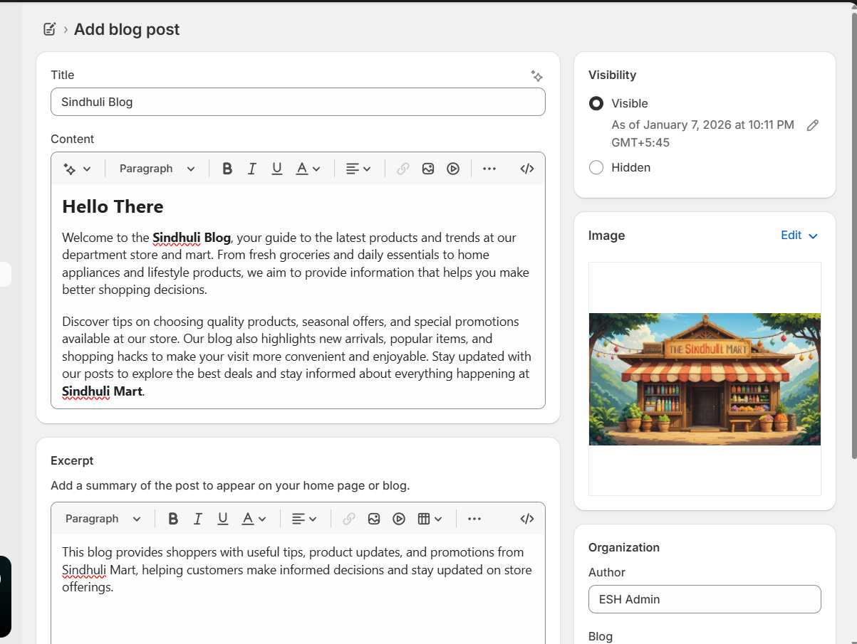

Figure 22: Blog Creation

Shopify Inbox enhances the store’s communication capabilities by allowing real-time chat with customers. This app helps answer queries, provide support, and engage visitors immediately, which improves customer experience. Even minimal use demonstrates how store owners can interact with customers beyond product listings, support trust-building, and encourage sales.

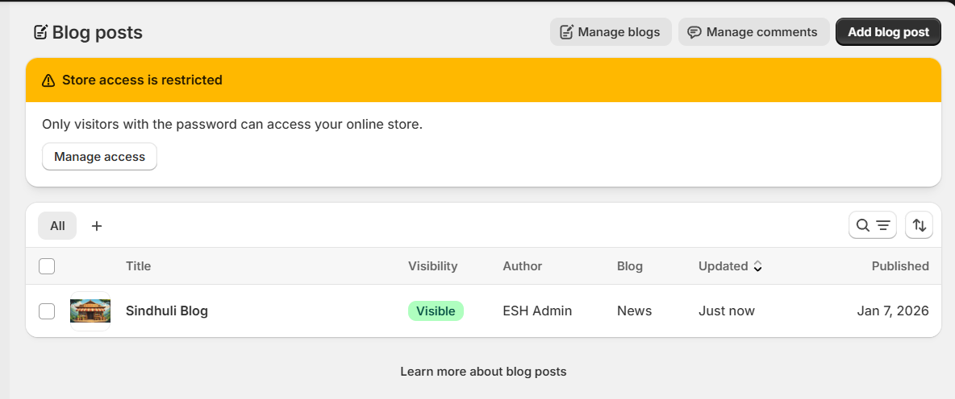

Figure 23: Blog List

Additionally, the app contributes to better store management by keeping track of customer messages and providing automated greetings, making communication more efficient and professional.

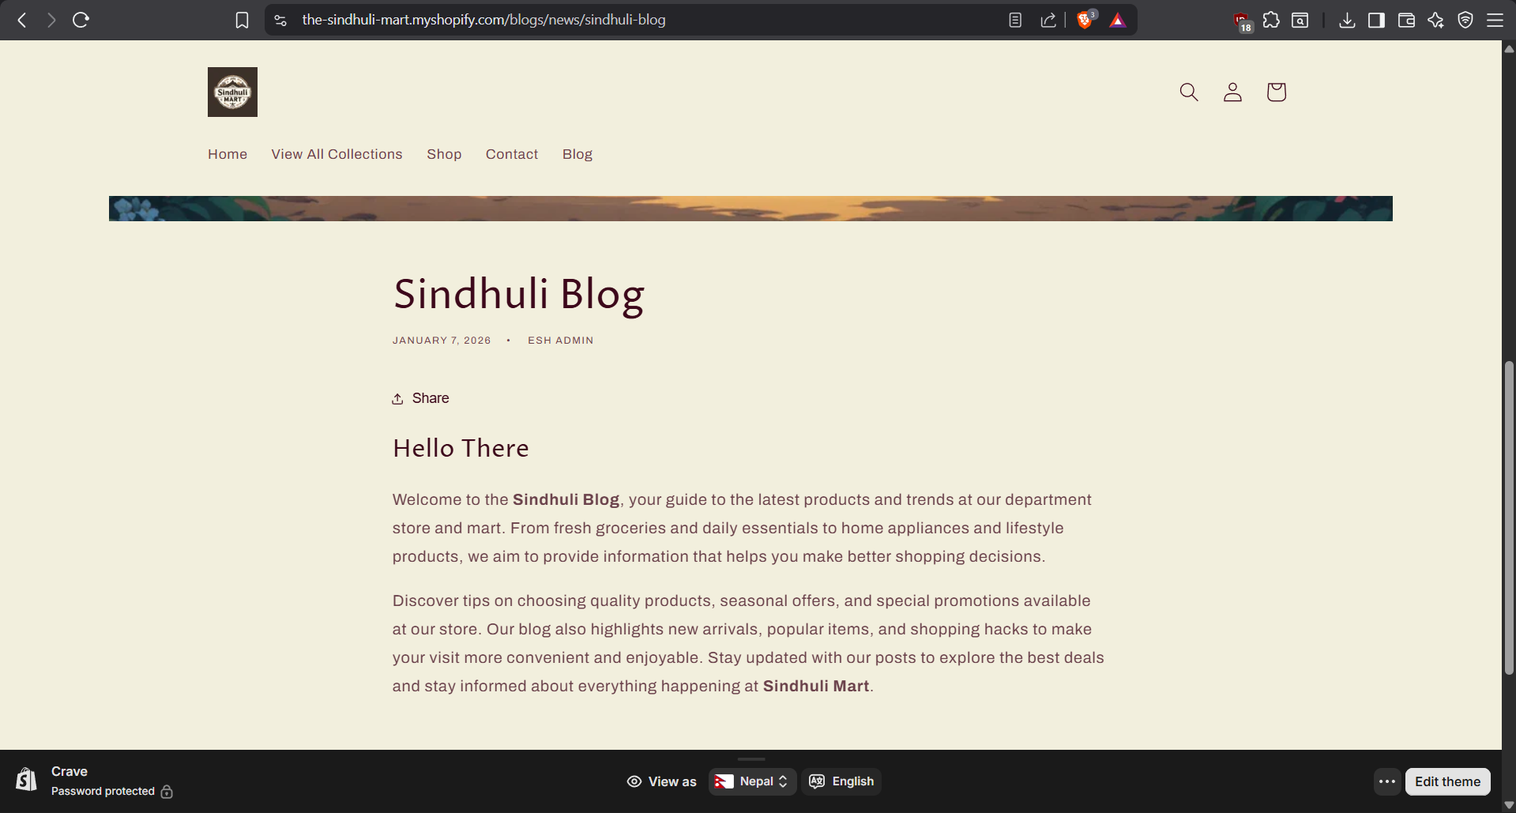

Figure 24: Viewing Blog

## LAB 4.1: Create a google analytics account

1. Opened the Google Analytics website and signed in with a Google account.
2. Clicked Start measuring to create a new analytics account.
3. Entered a name for the account and proceeded to configure a new property.
4. Selected Google Analytics 4 (GA4) as the property type.
5. Provided the e-commerce store name, reporting time zone, and currency.
6. Chose Web as the data stream type and entered the store’s website URL.
7. Completed the setup and saved the property settings to enable analytics tracking.

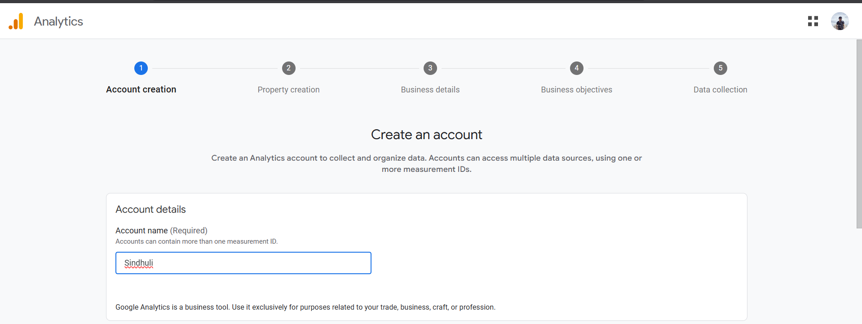

Figure 25: Account Creation For Google Analytics

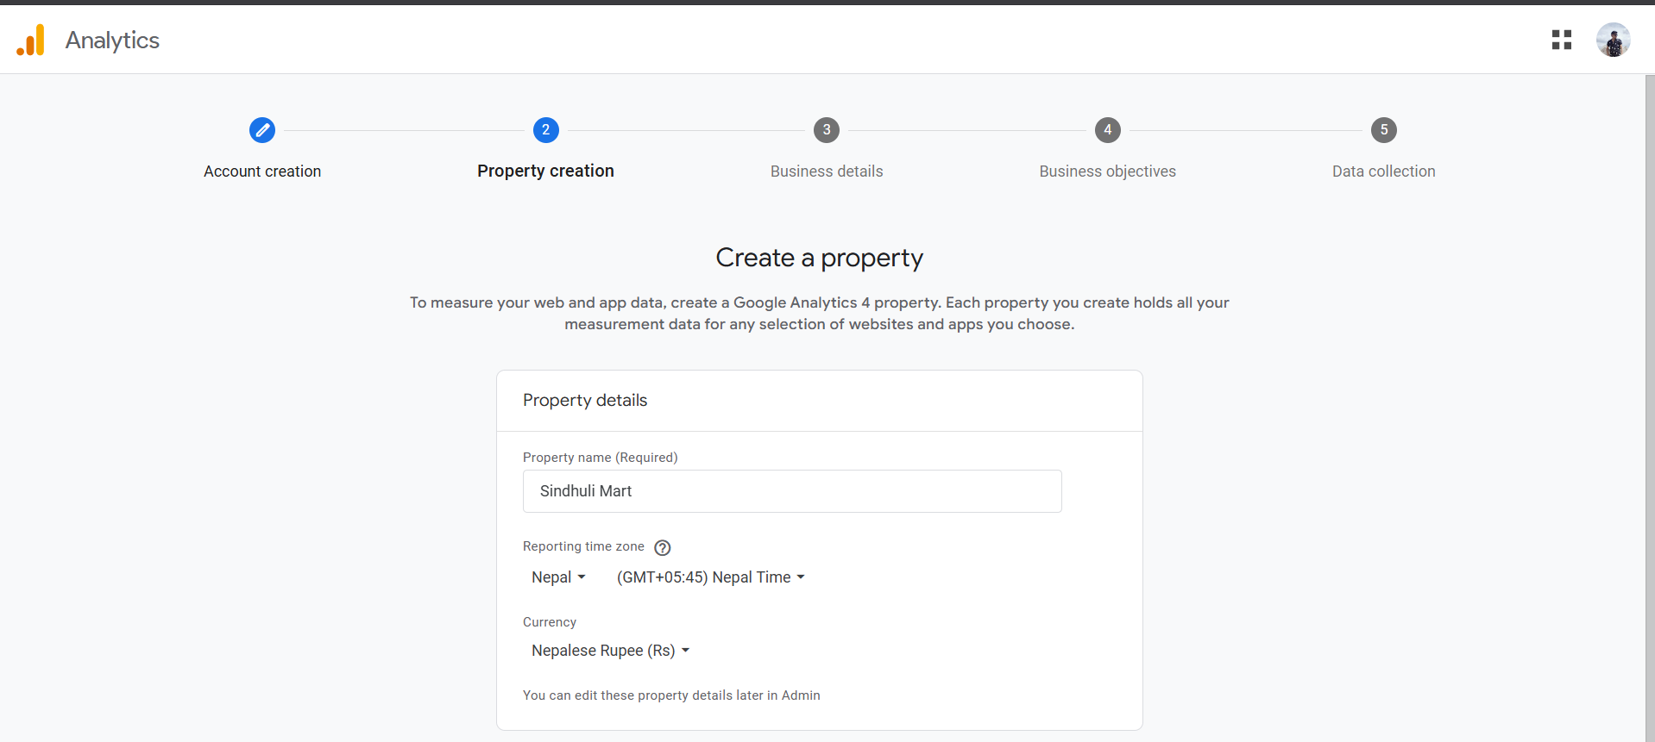

Figure 26: Property Creation

Adding Google Analytics to the Shopify store provides valuable insights into customer behavior and website performance. It allows tracking of visitors in real time, identifies traffic sources, and highlights popular products and pages. By analyzing this data, store owners can evaluate marketing effectiveness, make informed decisions to improve the shopping experience, and identify trends that support long-term growth and better customer engagement.

## Add Google Analytics Tracking Code to Website

1. Accessed the Shopify Admin Dashboard by logging in.
2. Went to Online Store → Themes and clicked Edit code for the current active theme.
3. Located the theme.liquid file under the Layout section.
4. Copied the Global Site Tag (gtag.js) from the GA4 property settings.
5. Inserted the tracking code into the <head> section of the theme.liquid file.
6. Saved the changes to ensure Google Analytics tracking was applied to all store pages.
7. Confirmed that data was being collected by reviewing Real-time reports in Google Analytics.

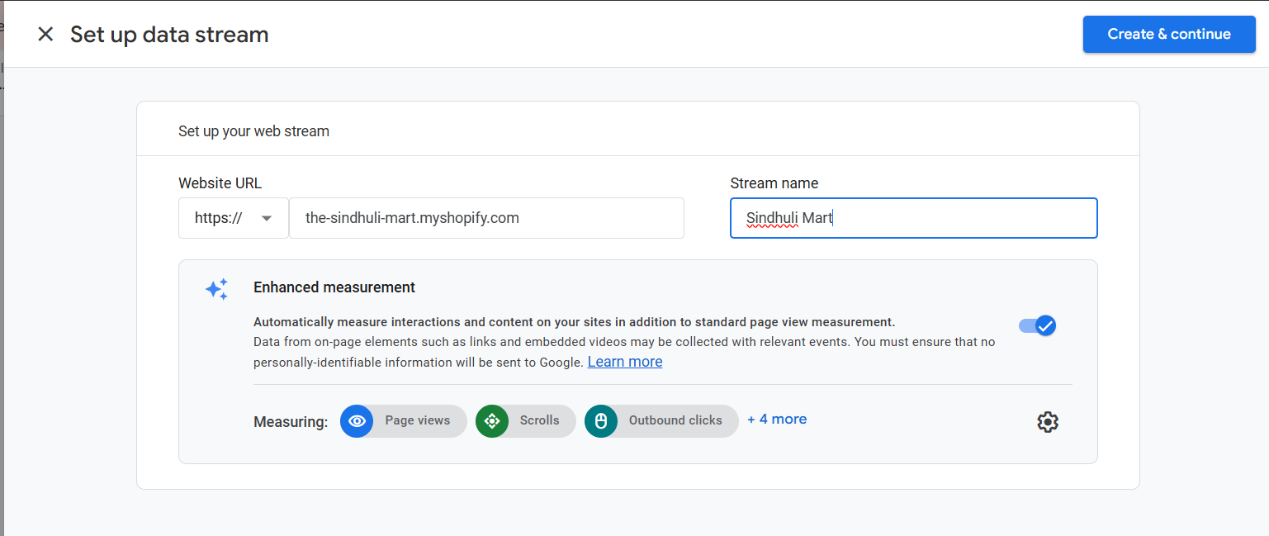

Figure 27: Data Stream Under Google Analytics

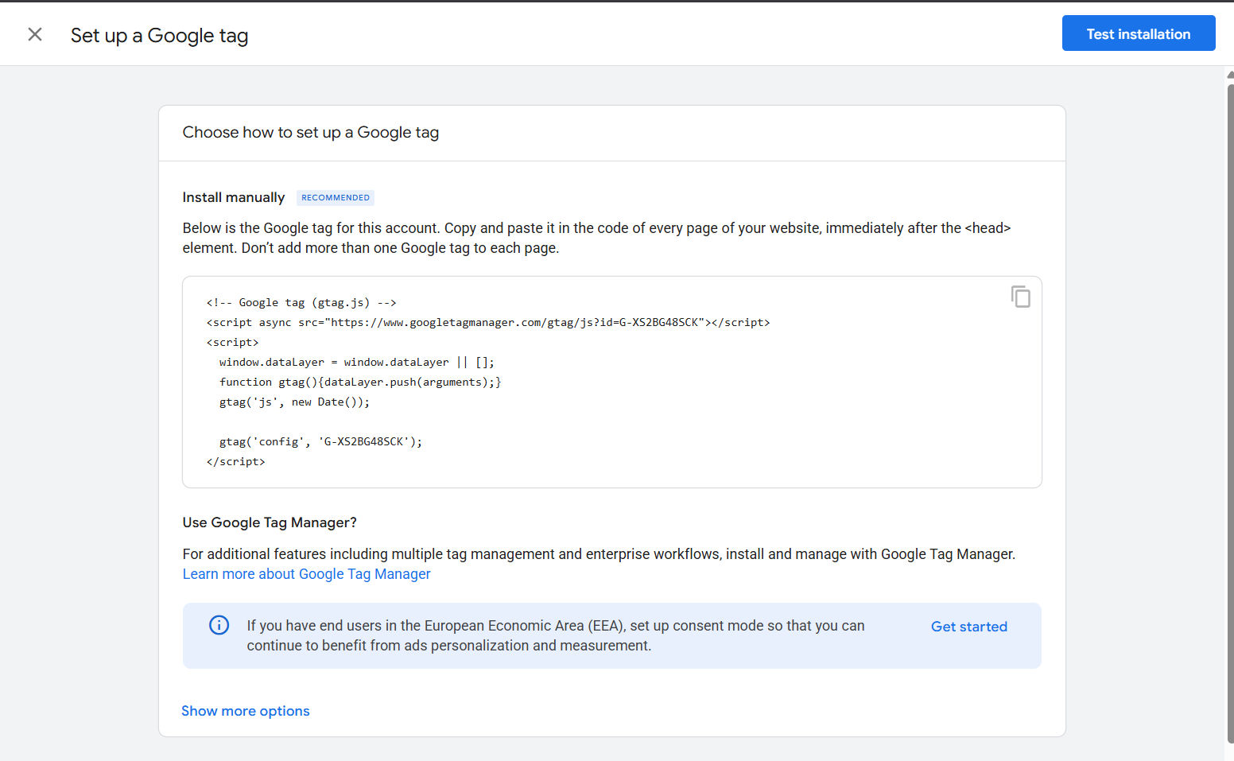

Figure 28: GA4 gtag setup

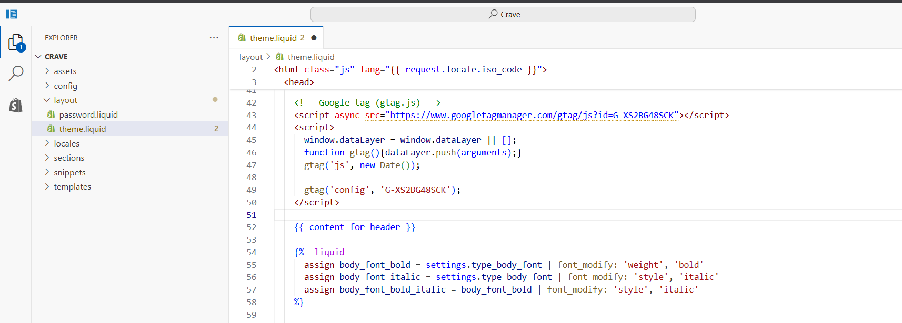

Figure 29: Added code in the head section of theme.liquid